**Confirmation Year II Class Schedule 2024 - 2025**

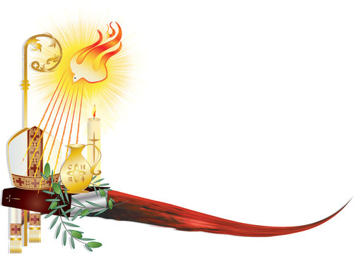

|  |
| --- |
| **SUNDAY 6:00PM – 7:30PM ROOM # 6** |
|  |
| **09/15/24 Parents and Candidate Meeting 4-5PM** |
| **09/22/24** |
| **10/06/24** |
| **10/20/24** |
| **11/01/24 Church – Holy Day of Obligation All Saints Day** |
| **11/03/24** |
| **11/17/24 Host Potluck Dinner 6-8PM** |
| **11/23/24 Confirmation Retreat 9-3PM** |
| **12/08/24 No Class - Church – Holy Day of Obligation** |
| **12/15/24** |
| **12/22/24 No Class** |
| **12/25/24 No Class – Church - Holy Day of Obligation** |
| **12/29/24 No Class** |
| **01/01/25 No Class - Church – Holy Day of Obligation** |
| **02/08/25 Charism Workshop with Sponsor/ or parent 9-1:30pm** |
| **02/09/25 No Class- Church - Superbowl of Caring Service** |
| **02/23/25** |
| **03/02/25** |
| **03/16/25** |
| **03/24/25 Youth Penance Service** |
| **03/30/25** |
| **04/06/25** |
| **04/18/25 Church – Outdoor Living Stations 8-12PM** |
| **04/20/25 Church – Holy Day of Obligation** |
| **04/24/25 Confirmation Rehearsal with Sponsor Church 7 pm** |
| **04/25/25 Sacrament of Confirmation and Reception 7pm TBA** |

**Natalia Nawrot**

**Director of Faith Formation**

[**n.nawrot@saintpius.org**](mailto:n.nawrot@saintpius.org)

**860-346-9100**