**Confirmation Year I Class Schedule 2024-2025**

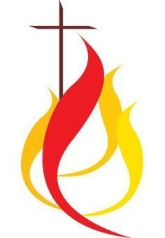

|  |
| --- |
| **SUNDAY 6:00pm – 7:30pm** |
|  |
| **09/15/24** Parents and Candidate Meeting 2-3PM |
| **09/22/24** |
| **10/06/24** |
| **10/20/24** |
| **10/27/24** |
| **11/01/24** Church – Holy Day of Obligation All Saints Day |
| **11/17/24** Host Potluck Dinner 6-8PM |
| **11/24/24** |
| **12/01/24** |
| **12/08/24** No Class - Church – Holy Day of Obligation |
| **12/15/24** |
| **12/22/24** No Class |
| **12/25/24** No Class - Church – Holy Day of Obligation |
| **12/29/24** No Class |
| **01/01/25** No Class - Church – Holy Day of Obligation |
| **01/26/25** |
| **02/09/25** No Class – Superbowl of Caring Service - Church |
| **02/23/25** |
| **03/02/25** |
| **03/15/25** Confirmation Retreat 9-3PM |
| **03/24/25** Youth Penance Service |
| **03/30/25** |
| **04/06/25** |
| **04/18/25** Church – Outdoor Living Stations 8-12PM |
| **04/20/25** Church – Holy Day of Obligation |
| **04/25/25** Church /Hall – (Host Party for Confirmation II/ Ushers**)** |

**Natalia Nawrot**

**Director of Faith Formation**

[**n.nawrot@saintpius.org**](mailto:n.nawrot@saintpius.org)

**860-346-9100**