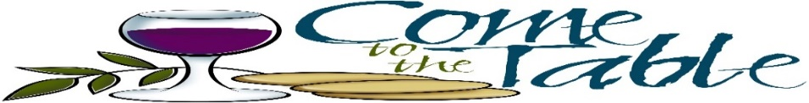
10/26/2024 Fall Fair 9AM - 3PM – Pumpkin Patch

11/01/2024 Holy Day of Obligation – All Saints Day – Attend Mass

12/01/2024 First Sunday of Advent

12/07/2024 “Waiting for Jesus” Advent Retreat 2pm – 4pm TBA
12/08/2024 Holy Day of Obligation - Solemnity of the Immaculate Conception of the Blessed Virgin Mary- Attend Mass

12/15/2024 Breakfast with St. Nick 8am -11am ( contact Friary office for tickets)

12/25/2024 Holy Day of Obligation - Christmas Day- Attend Mass

01/25/2025 Family Bingo Church Hall 6pm

01/01/2025 Holy Day of Obligation Solemnity of Mary – Attend Mass

02/09/2024 Coffee Social - All Faith Formation children to participate TBA
03/05/2025 Ash Wednesday – Attend Mass 7:00pm

03/09/2025 Lent Begins

03/08/2025 1ST Eucharist Retreat 2:00pm – 4:00pm TBA

03/09/2025 - 04/11/2025 Lenten Fish Dinner every Friday during Lent 6:00pm (tickets can be purchased at the Friary office) Stations of the Cross 7:00pm TBA

03/14/2025 1ST Eucharist Mass Instructions Church 4:30pm – 5:30pm TBA
03/24/2025 Youth Penance Service 7:00pm
04/12/2025 Easter Egg Hunt 1:00pm
04/18/2025 Outdoor Living Stations 12PM

04/20/2025 Holy Day of Obligation – Easter Sunday – Attend Mass

05/06/2025 1st Communion Rehearsal 4:00pm – 5:15pm
05/08/2025 1st Communion Rehearsal 4:00pm – 5:15pm
05/10/2025 SACRAMENT OF FIRST HOLY COMMUNION 10:30am
(Children to arrive at the Church Hall at 9:30am) TBA
05/11/2025 Crowning of Mary 9am Mass
(Please attend Mass wearing your First Communion outfit)
PLEASE MARK YOUR CALENDARS FAITH FORMATION 3RD GRADE STUDENTS & FAMILIES

